Overview
Regulations mean the end of the tungsten filament lamp, in time these will extend to the halogen dichroic lamp. This note discusses how you can deliver attractive, energy efficient lighting in your home and business.

WebBricks are now an essential part of your lighting scheme. This is because part L of the building regulations demand that you install a fixed proportion of non-interchangeable low energy fittings.

WebBricks can be used to control and co-ordinate a wide range of lighting technologies.

What was good about tungsten?
There were three factors that made tungsten an asthetically attractive light source:

- Wide Spectrum the light output contained a good mix of all colours, red – blue. This meant that colour rendition (the perceived colour) was good.
- No Flicker because of the thermal element the light source barely cooled across the AC cycles of mains supply.
- Red Shift Dimming as Tungsten lights were dimmed their light output shifted towards the red end of the spectrum. This gave a pleasing warm light at low levels.

Making the best use of low energy lighting
There are a wide range of low energy lamp technologies, the four key examples are:
- Compact fluorescent (CFL)
- LED
- Cold Cathode
- Electro Luminescence (EL)
Each of these have different applications and efficiency. We should also note that technologies are changing fast as tungsten needs to be replaced.
CFL has a good output for energy input.
LED is good for controlled spot illumination and colour based strip lighting.
Cold cathode is fairly new but good for a compact efficient light source.
EL is mostly used in single colour back light applications.
Colour Temperature
In the tungsten world we got pretty much as we were given, because it was about right. There were some exceptions, for example the 'daylight' balanced lamp.
The newer lighting technologies have a colour sweet spot where their efficiency is best. You may have noticed this in public buildings such as hospitals where the light seems harsh or sharp. These buildings use mostly CFL lighting because it gives the maximum output per watt of energy, CFL is at its best output with a light that has more blue/green components in its spectrum.
Colour temperature is measured in terms of what a perfect back body would look like at a temperature measured in Kelvin (Correlated Colour Temperature). Here are some examples:
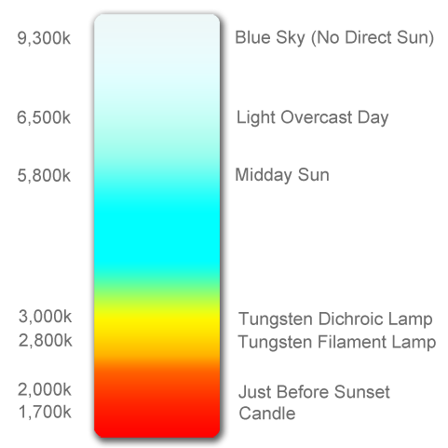
When buying lamps we need to match the rated colour temperature to the application. To get a wider spectrum of light it is common to add impurities in the manufacture of lamps. These impurities will resonant at different frequencies and hence broaden the spectrum, but at the cost of efficiency.
When lighting the corridors of public buildings, regulations need to be met at minimum energy loads. However in a kitchen it is important that we see the proper colour of food.
People find people more attractive when lit at the lower end of the spectrum, hence the candle lit dinner.
A common pitfall is to mix colour temperatures in the same area, this causes a visually jarring effect. Installers need to document what colour temperature was used so that customers can source correct replacements.
Using Colour
RGB LEDs can generate almost any colour, and just because they can it doesn't mean that all colours are useful.
When a colour is reflected from a wall or ceiling the colour of the surface will be subtracted from the LED light.
LED strips are becoming more and more affordable whilst improving efficiency. Whilst this is a good thing, it makes batch availability poor.
If LED lighting is used to provide an accent colour it is important to ensure that all LEDs come from the same batch.
It is possible to have too much of a good thing, the use of multiple accent colours can be visually jarring (except for Christmas where normal aesthetics do not apply).
Pale accent colours can clash, especially those close the near white output of adjacent lamps. If you find a clash but still want to use the accent then use scenes to separate them. This make work very well where just the accent lighting is used for some room purposes (e.g. visual entertainments).
Warm accent colours (those rich in red content) can help offset the effect of narrow spectrum CFL lighting.
RGB LEDs can be used with WebBricks in a number of configurations:
- DMX – high power applications, external building colour wash
- 0-10V – high power applications driving multiple constant current lumineres
- Direct connection to Mimic channels – LED RGB Strips
Dimming and avoiding Flicker
Each lamp technology requires a different approach to dimming. As a general rule you should use the method that best matches the technology.
A useful development is the HF dimmable ballast, which allows for instant start dimmable usage of CFL and fluorescent tubes. In design terms you need to be aware that the dimmable range is around 7-100%. As light is perceived on a logarithmic basis, 7% will be seen as quite a high light level and users will often want lower lighting levels.
Generally dimmable HF ballasts are available with 0-10V control, this is ideal for WebBrick connection.
This is where a combination of lighting technologies is useful. CFLs can give the high light levels needed, whilst LED technologies can provide the low levels and desired colour temperature.
However many manufactures are producing lamps for the retro-fit market. These 'read' the dimming that would have been applied to tungsten lamps then convert this to energy levels. There are a number of pitfalls here, in particular there are regulations regarding RFI, which means modern lamps have RFI suppression built in. Dimmers designed for tungsten technologies expect to see a resistive load whereas low energy lamps will become reactive in the mid range. The success of dimming new lamps with old dimmers is often down to the number of lamps in the circuit rather than the overall load (which will be much less than the equivalent tungsten load). The more lamps, the more RFI suppression the dimmer sees and the more likely it is to hunt in the 20-80% dimming range. It is this hunting that causes flicker.
Older ballasts for CFL and fluorescent lamps would flicker at 100Hz, these are being replaced by high frequency (HF) ballasts but many of the old type remain regardless of market position.

Changing face of LEDs
At the time of writing CFL and fluorescent have the efficiency edge delivering more lumens over a greater area per watt of energy.
However this lead is being eroded on a daily basis. The buyer needs to be aware of 'specmanship' where LEDs are often quoted against a narrow light beam.
At WebBrick we are regularly offered samples of LEDs, some recent offerings have been very strong on light output: a 5W LED able to replace a 35W dichroic, however the dimmable range is still limited.
Always remember to test LEDs in the quantity you need over the dimming range you want.
DMX
This is a useful control protocol that has its roots in the theatre and concert world. It was designed for reliability and flexibility where fittings could be changed 'mid-event'
DMX controllers have become quite popular for LED applications, this is because the initial high cost fittings were used in retail and architectural illumination where regular changes add dynamic interest.
As prices fall DMX lends itself well to home applications
Can we help?
If you need more information on WebBrick low energy lighting solutions, please contact us.

2010 Oct Regulations require the lighting to be calculated as part of the TER
See the common pitfall in colour temperatures

